**Title: Implementation of Decision Tree**

Theory:

**Decision Tree**

A decision tree is a popular and intuitive tool used for classification and decision-making tasks in machine learning and data analysis. It models decisions and their possible outcomes as a tree-like structure.

**Key Features of Decision Trees:**

1. **Root Node**: Represents the starting point or the initial condition of the decision.
2. **Decision Nodes**: Intermediate points that represent a condition or a test on an attribute.
3. **Leaf Nodes**: Terminal points of the tree that represent the final decision or classification.
4. **Branches**: Paths that represent outcomes of conditions or tests.

**Construction of a Decision Tree:**

* **Splitting Criteria**: The data is split into branches using metrics like Gini Impurity, Entropy, or Information Gain.
* **Pruning**: Reducing the complexity of the tree to prevent overfitting.
* **Recursive Partitioning**: The process of repeatedly dividing data based on attribute values.

**Decision Table**

A decision table is a tabular representation of conditions and their corresponding actions or outcomes. It provides a systematic way of organizing rules and making decisions based on multiple criteria.

**Key Components:**

1. **Conditions**: Variables or attributes that influence the decision (e.g., age, financial status).
2. **Actions**: Possible outcomes or decisions (e.g., eligible, not eligible).
3. **Rules**: Combinations of conditions that lead to specific actions.

**Structure of a Decision Table:**

* **Condition Columns**: Represent the conditions being evaluated.
* **Action Columns**: Represent the decisions or outcomes.
* **Rules Rows**: Contain specific combinations of conditions and their corresponding actions.

A brokerage firm wants to evaluate whether an individual is eligible for share trading.

Conditions:

1)Age

-18 years or older(eligible)

-under 18 years (not eligible)

2) Identity Verification

-Document verified(eligible)

-Document not verified (Not eligible)

3)Financial status

-Monthly income above $2000(eligible)

- Monthly income below $2000(Not eligible)

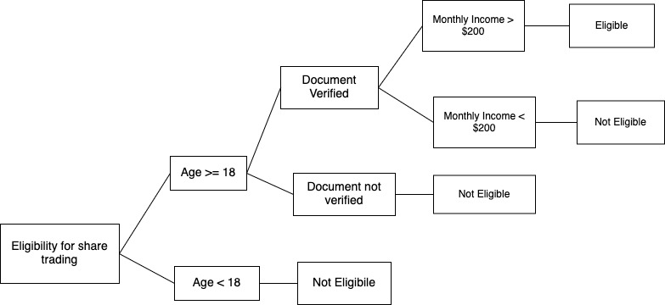**Decision Tree:**

Decision Table:

|  |  |  |  |  |
| --- | --- | --- | --- | --- |
| Conditions | Rule 1 | Rule 2 | Rule 3 | Rule 4 |
| Age | >=18 | >=18 | >=18 | < 18 |
| Identity Verification | Verified | Not Verified | Verified | - |
| Financial Status | >= $200 | - | < $200 | - |
| Eligibility | Yes | No | No | No |

Conclusion: In this lab, the implementation of the decision tree was successfully completed to evaluate the eligibility of individuals for share trading. Conditions such as age, identity verification, and financial status were considered, and the rules were clearly defined. The decision tree structure was constructed, and eligibility outcomes were determined based on the provided conditions.

The decision table was created to systematically represent the rules and their corresponding outcomes. This ensured that all possible combinations of conditions were accounted for, and the decision-making process was simplified. The results demonstrated the effectiveness of using decision trees and decision tables for structured decision-making.